Will Quantum Technology be relevant in Future Displays?

Can Quantum Technology improve Displays?

**Meta**

*This article explains and evaluates new display technologies based on quantum dot semiconductors. For this, biologically reasoned criteria are introduced and used to compare these new technologies to current successful methods.*

One thing is sure. Our digitalised world wouldn’t be possible without displays and the demand for energy efficient, cheap and realistic presentation of information is higher than ever. The most successful display technologies currently on the market are LCD and OLED displays but tech companies like Samsung already started to introduce so called QLED TV’s. Sounds close to OLED you might think, but the difference is more fundamental than the name suggests. The new technology here is the use of so called Quantum Dots to improve colour purity, efficiency and many other things.

Lets dive quickly into the relevant physics.

In semiconductors there is a range of energies the electrons can’t have, the so called band gap. This band gap usually separates the mostly filled energy states which are the valence electrons that bind the atoms of the material and the higher and mostly empty energy states of conducting electrons. ~~These energy states are also called valence band and conduction band.~~ A quantum dot is a often spherical piece of semiconductor, for example cadmium sulfide (CdS), with a size in the range of nanometres. In that regime its band gap changes significantly from its initial value. For example in the case of CdS, which typically has a band gap of 2.6eV the band gap can be increased up to 3.5eV [Brus1998].

If an electron of a higher energy state changes into a lower energy state, the energy difference is emitted as light of a certain wavelength $\lambda$ given by $E=\frac{h}{\lambda}. By varying the size of the quantum dots it is possible to create materials that can emit almost any colour [ElectronElectronBrus]. ~~Also, the light emitted by this process is very pure compared to conventional methods~~

Our eye perceives colour over so called cones, sensors for red, green and blue light. An ideal display matches our natural perception of objects by transmitting a mixture of these three colours. The set of colours a display can represent is the colour gamut that can be represented in the so called CIE 1932 chromaticity diagram shown in figure [fig]. Colours close to the edge have single wavelengths and going to the middle we find mixtures of these colours. The gamut of a display is represented by the area of the triangle between the three primary colours as shown in figure . The wider the gamut the colourful display seems to us.

Quantum dots emit light with very narrow peak widths compared to typical organic emitters in OLEDs or color spectra from lcd screens. This makes it possible to achieve much wider gamuts than currently on the market.

Other factors of consideration are also the brightness of the display and its operational lifetime.

The brightness of the emitted light is strongly dependent on the Quantum Yield? Efficiency? Operational lifetimes can be extended by coating the quantum dots in other semiconductor materials that additionally should not react with surrounding materials

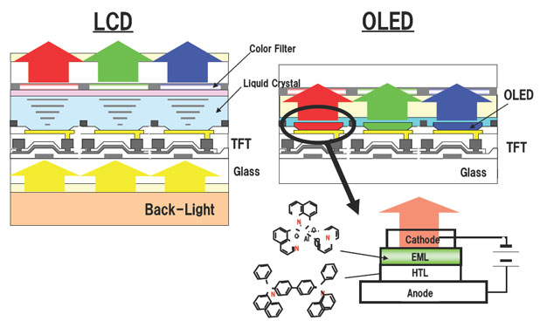

This mechanism can be implemented into displays in two different ways. The first way is the down conversion of blue light into green and red light, also called photoluminescence. The incoming blue photon excites an electron over the band gap. Usually, the photon doesn’t recombine directly but loses energy to the semiconductor lattice until it reaches the band gap. From there it recombines with the free electron state it created and emits a photon of the colour corresponding to the band gap width.

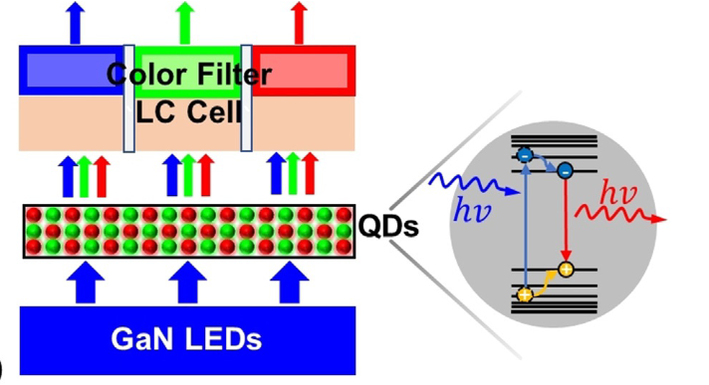 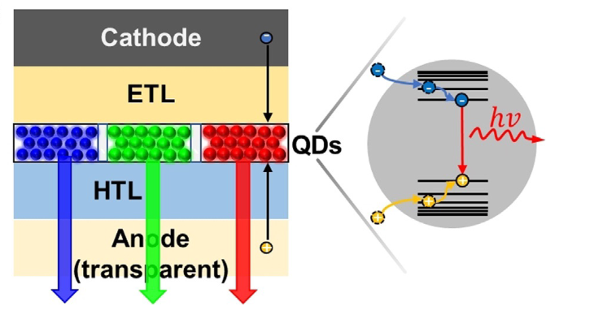

The colour gamut of LCD screens, which work on a white backlight with colour filters for red and green colour can be improved significantly by using quantum dots. In a first step currently marketed by Samsung as QLED TV’s [ref], a blue LED light source is combined with a layer of colloidal quantum dots for green and red colour instead of yellow phosphor. This makes possible a wide colour gamut but can only be a intermediate solution. The light source still creates much more light than is used in the end for the creation of the picture [Shu]. Also, the contrast, the maximal difference in brightness on the screen is limited by the remains of backlight coming through switched off pixels. This is a large disadvantage to OLED screens which can switch of pixels completely and thus also save additional power. [µLEDLiu]

A different approach using photoluminescence is to exchange the backlight by µLED’s for each pixel to fix the disadvantage in contrast compared to OLED. The µLED’s emit blue light that is then converted to green and red light by quantum dots directly in the pixel. The challenges with this method are the so called cross talk, the lighting of deactivated pixels by neighbouring LED’s and remaining blue light in pixels with different colours. These effects can be controlled by introducing additional light barriers and altering parameters, but make the fabrication process more expensive.

On the other hand, this approach can combine a wide colour gamut and high contrast which removes the major disadvantages of LCD displays and outperforms current OLED’s. It shows also a higher stability in brightness and colour over time and environmental changes that trouble OLED TV’s. Even largest problem of OLED’s, the so called “burn in” of frequently shown patterns with on the same set of pixels doesn’t occur on those QD-µLED TV’s because their lifetime is significantly larger [µLEDLiu].

*A second more advanced approach would be to replace the filtering for each colour by a film of corresponding quantum dots [ctarticle]*

*Instead of the colour filters, quantum dots for the right colour are dispersed in a polymer solution and which is then placed in the pixel*

*So, to produce a colour from a quantum dot one only needs to introduce excited electrons and corresponding free states in the quantum dot.*

Although all this sounds very promising, there is a lot of engineering involved to improve photoluminescent quantum dot displays which makes them more expensive. A different physical approach to create light from quantum dots is by electroluminescence, which lets them emit light without another primary light source. The colloidal quantum dots are placed between two semiconductor layers as seen in figure [ref] which supply free electrons from one side, the electron transport layer (ETL), and so called holes from the other side, the hole transport layer (HTL). Holes are not occupied electron states in an environment of occupied states. It is possible to model them as particles with positive electron charge. Through that setup, holes and electrons recombine in the quantum dot, emitting light with band gap energy.

This concept promises to be even better than the other methods presented so far. Light of a certain colour is only emitted when needed which saves a significant amount of energy and the high contrast ratio of µLED and OLED screens can be maintained. Saving energy equivalently also means potential higher brightness [ctarticle]. The solution processability of Quantum Dots and the relatively simple structure of QLED TV’s is also likely to lead to cheaper production costs than current OLED’s.

Problems?

Heavy Metals?

A major problem for implementing Quantum Dots still remains. The semiconductors used for creating light in the optical spectrum involve heavy metals like Cadmium in CdSe. These are usually heavily regulated by governments. However, for the current Quantum Dot TV’s it was possible to reduce the heavy metal concentrations below the set thresholds [Shu]. Another way would be to use different materials. InP could replace CdSe for red and green Quantum dots. In fact, Indium is a regulated heavy metal too, but it is allowed in much higher concentrations. The only problem with replacing Cadmium completely by Indium would be the creation of blue Quantum dots. Here, a solution still needs to be found.

Overall, we see that the use of Quantum Dots can significantly improve the weaknesses of our current technology including OLED TV’s. I’m sure we will see more of these in near future.

**Physical Requirements of a Display**

Color gamut, Brightness, Operational lifetime

**Explain physical functionality of the different methods**

Spectral differences to other methods

Backlit Qdot displays:

* Samsung QLED (QD-LCD), QD-µLED
  + Structural implementation
* Advantages:
* Disadvantages:

Self Emitting Quantum dots:

* True QLEDs
* Comparison to OLEDs

Describe optimal parameters for a good display

* Color gamut
* Color stability
* Energy efficiency
* Possibility for downscaling

How can Quantum Dots emit light?

